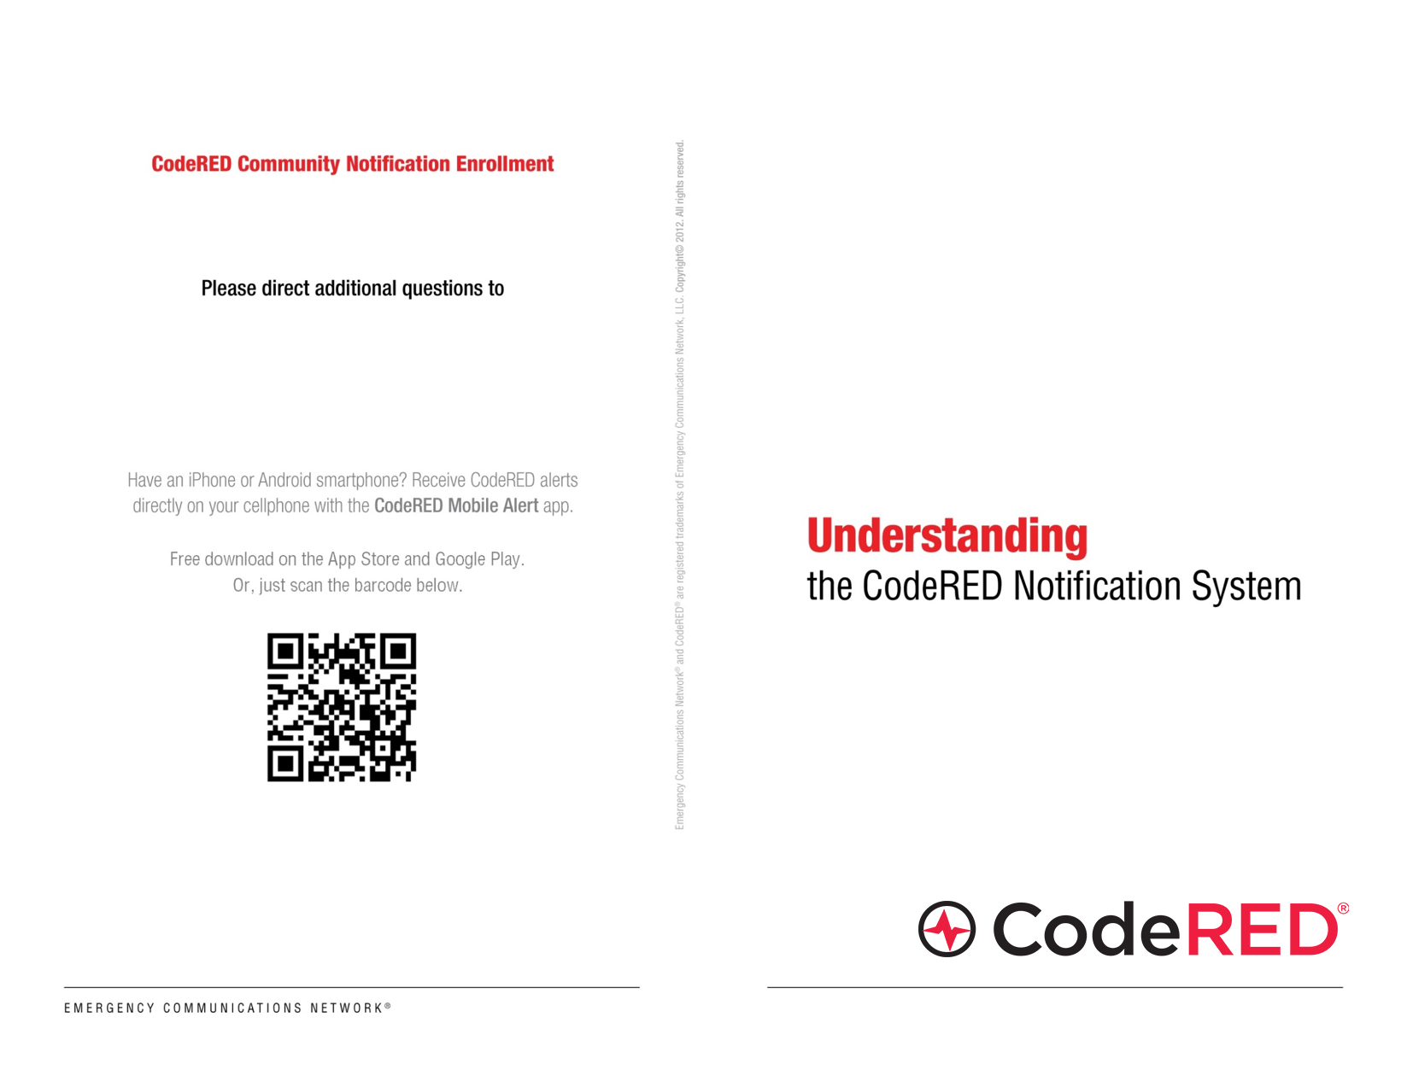

**Sarah Bennett, Director**

**Sagadahoc County Emergency Management Agency**

**(207) 443-8210**

[**sbennett@sagcounty.com**](mailto:sbennett@sagcounty.com)

[**http://sagcounty.com/departments/ema/emergency-notification**](http://sagcounty.com/departments/ema/emergency-notification)

**OR**

**Like us on Facebook and click the SIGNUP button!**



**What is CodeRED and why is it important to me?** CodeRED is an emergency notification service that allows emergency officials to notify residents and businesses by telephone, cell phone, text message, email and social media regarding time-sensitive general and emergency notifications. Only authorized officials have access to the CodeRED system.

**When will CodeRED be used?** Any message regarding the safety, property or welfare of the community will be disseminated using the CodeRED system. These may include AMBER alerts, notifications of hazardous traffic or road conditions, boil water advisories or evacuation notices.

**Does the CodeRED system replace other systems that have been used to provide time-sensitive information to residents?** This system is an enhancement to existing means of communication and is meant to supplement current or past systems used for mass notification.

**Does the CodeRED system already have my telephone number, or do I need to sign up to receive CodeRED notifications?** The CodeRED database contains information received from public databases, including regional phonebooks. However, no resident should assume that their information is in the system. The EMA page of the County of Sagadahoc website, http://sagcounty.com/departments/ema/emergency-notification/, has a link to the CodeRED Community Notification Enrollment page where you can register online. If you can not register online, you can call 207-443-8210 and speak with one of our Emergency Management specialists to complete your registration over the telephone.

**I have a business located in Sagadahoc County. Can I arrange to have CodeRED contact my business?** Yes. Fill out the CodeRED registration form but be sure to select the “This address is a business” option. Please note that emergency calls can only be delivered to a direct dial number. Automated attendants will disrupt the process and the calls will not be delivered. Businesses should register their main number and establish a procedure for distributing the CodeRED message to their workforce.

**What if I want to register additional numbers for my address?** After you submit the initial registration form, you may start the registration process again and submit more numbers for the same address.

**Is my personal information protected?** CodeRED is a service of Emergency Communications Network which takes security and privacy concerns very seriously. They will not sell, trade, lease or loan any citizen supplied data to third parties.

**How will I recognize a CodeRED message?** A CodeRED Emergency message will have a caller ID of 866-419-5000. A CodeRED General message will have a caller ID 855-969-4636. We suggest you program both numbers in your cell phone as a “new contact” and use “CodeRED Emergency” and “CodeRED General” as the contact name. If you need to replay the emergency notification message again, simply dial the number and you will be able to hear the message again.

**What should I do if I receive a CodeRED message?** Listen carefully to the entire message. You will have the option to repeat the message by pressing any key. Do not call 911 for further information unless directed to do so or if you need immediate aid from the Police or Fire department.

**I have a landline, and it does not work when the power goes out. How will the system be able to contact me?** Make sure you have at least one working corded telephone – and be sure to turn the ringer on. The CodeRED sign-up form allows you to indicate both a primary and alternate phone number. Cell phone and/or work phone numbers can be entered as alternate phone numbers. Both primary and alternate phone numbers will be contacted when a notification is sent.

**Will the CodeRED system leave a message on an answering machine?** Yes, the CodeRED system will leave a message on a machine or on voicemail. The CodeRED system will leave the entire message in one pass.

**What happens if the line is busy?** If the line is busy, CodeRED will try two more times to connect.

**What circumstances might prevent a message from being delivered to me?**

* If your contact information has changed and you have not registered your new information.
* If you only have a landline at your residence, the power is out and you did not register an alternate phone number.
* If your line is busy for an extended time and your calls do not forward to voicemail or an answering machine.
* If you have a privacy manager on your main phone and you did not register an alternate phone number.

Sagadahoc County staff will receive a report of undelivered calls and can instruct the CodeRED system to begin another round of calls to busy numbers. It is best to have an alternate phone number in the calling database for these situations.

