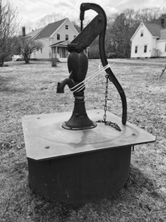WATER CONSERVATION MEASURES

Investments

* Inexpensive add-ons like water saving shower heads, faucets, and toilet features available at hardware stores.
* Cistern to collect rainwater.
* If your appliances are older than 10 years, consider investing in new appliances.
  + Water saving dishwaters and front-loading washing machines are two examples.

Leaks

* Check for leaks in the toilet bowl by adding food coloring. If the water becomes clear after a short time without being flushed, there is a leak.
* Check garden hoses for leaks.
* Repair or replace leaky faucets.
* Wait to run the clothes washer until you have a full load.
* Set appropriate water level for your load.
* Try to wear clothes as many times as you can before washing them.

Kitchen

* Compost to limit water wasted with garbage disposal.
* Clean fruits and vegetables in a container filled with water rather than running water.
* Instead of running water until it is hot enough to use, heat it in the microwave or capture the running water to use in another way. This is not necessary if you have on-demand hot water heaters.
* Have a filtered water pitcher place in rented households so renters have access to clean drinking water. This is a cheap investment.

Laundry

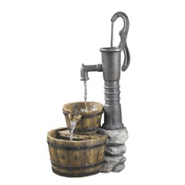

HELPFUL TIPS

Please remember most people in Georgetown are using water from **bedrock wells** that can run dry and not a municipal water system.

Prepared by the University of New Hampshire Environmental Engineering Program and the Georgetown Conservation Commission, 2021.

* Place wet clothing on a drying rack or clothesline instead of using a dryer.
* Turn off the lights when no one is using a room.

Energy

* Keep drinking water in the fridge so it will stay chilled instead of running the faucet for cold water.

Drinking Water

* Do not keep the faucet running when brushing your teeth, shaving or washing your face.
* Take shorter showers and avoid taking baths.

If you are interested in learning more about water conservation and want to discover more ways you can help, visit the following websites:

* <https://www.ready.gov/drought>
* <http://www.epa.gov/watersense/drought-watersense>
* <http://www.wateruseitwisely.com/100-ways-to-conserve/>
* <http://www.georgetownme.com/?page_id=39>

For more information…

Bathroom

Kitchen

* When hand-washing dishes, use large containers for washing and rinsing.
* Only use the dishwasher for a full load and use a “light wash” feature.